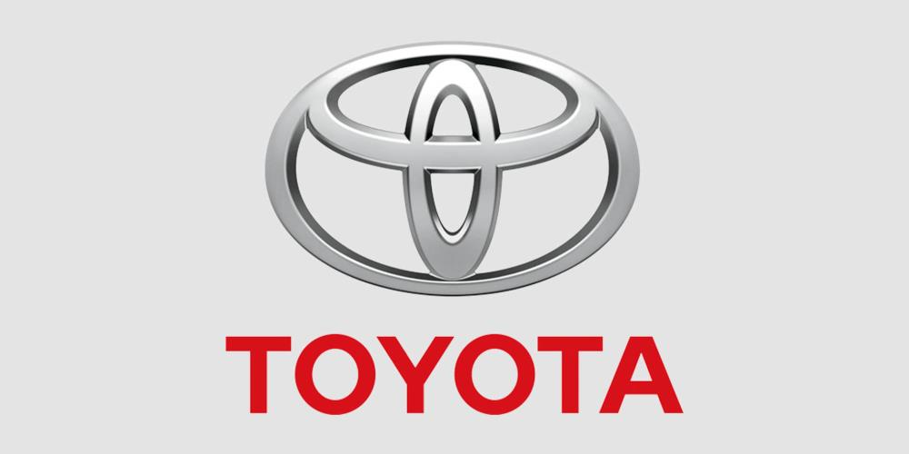

**Group Information**

|  |  |
| --- | --- |
| Name | Student Id |
| Adrian Alamu | S11209521 |
| Khushal Lal | S11215199 |
| Nivriti Sharman | S11210698 |
| Jessie Hill | S11210408 |
| Sisilia Valeca | S11213280 |

**Table of Content**

1. Introduction ……………………………………………………..………………..3
2. Company Background………………………………………………………….3
3. Literature Review………………………………………………………………..4

3.1 Open systems in the economy/organization………………………..4

3.2 Input, Throughput, and output in theory……………………………..5

3.3 The input, throughput, output in the automobile industry……5

3.4 How input infkuences output………………………………………………..6

4. Methodology…………………………………………………………………………..6

5. Findings…………………………………………………………………………………..6

5.1 Performance of Toyota………………………………………………………….6

5.2 Detailed process flow of Toyota…………………………………………….9

6. Discussion……………………………………………………………………………….10

7. Conclusion………………………………………………………………………………10

8. Reference……………………………………………………………………………….11

1. **Introduction**

First off let’s start with what is open systems. An open system is when the company becomes mixed with its external environment and it gets its resources/inputs from the environment. The company then performs according to the feedback it receives from the external environment (customer review/satisfaction). It is a system that involves the process of input, throughput, and output. This report will outline the processes affiliated with open systems in depth in relation to the automobile industry. And how input affects output of firms particularly Toyota motor corporation, and how the company manages to satisfy their customer base and get the upper hand in the market.

1. **Background-Toyota**

Toyota is one of Japan’s pinnacle automobile manufacturing agencies and is recognized for its best products across the globe. Toyota motors have been founded in the year 1937 by Kiichiro Toyoda and have its headquarters in Aichi, Japan. Toyota has around 338 thousand employees (about half of the populace of Wyoming) across the globe and has an extensive variety of cars presented to customers. Toyota's mission statement is to provide “high valued merchandise and offerings to its customers” whilst the imaginative and prescient declaration is to “be the most effective and respected vehicle corporation across the globe.” The document is going to cowl designated Process go with the flow adopted by means of Toyota to manage vehicle manufacturing and capable to similarly hyperlink it with business strategies and outline metrics to manage operational strategies. The potential evaluation is to be linked with commercial enterprise strategies and able to produce enhancing the metrics.

**3. Literature Review**

***3.1 Open system in the Economy/Organizations***

The classical-Keynesian approach has highlighted that labor costs are only one part of total costs. Costs of production are equal to value-added and the cost of secondary production (Pasinetti, 1977, 1981; Zambelli, Fredholm, and Venkatachalam, 2017). Inputs can be broken down into wages, raw materials, and profits so that total costs of production can be considered equal to the sum of wages, Raw material cost and profits made up in all stages of production (Shaikh, 2016, chap. 9). Therefore, the combination of the decomposition of the supply chain in terms of employment and value-added allows for determining relevant differences in the cost structures within the supply chains. This establishes how input and processing affect the quality of output and in turn determines the level of customer satisfaction. (Fana, M., & Villani, D. (2021).

***3.2 Input, Throughput, and output in theory***

The beginning of the production starts with input. In an open systems theory, organizations regulate technical flows between input, throughput, and output processes that are connected to the organizational environment (Katz & Kahn, 1978; Scott, 2003). Like all organizations, public organizations depend heavily on their external environment for survival. Interactions with the interdependent environment provide public organizations with the necessary information and resources to achieve their goals. Examples of these resources are people, knowledge, money, services, and technology (Pfeffer & Salancik, 2003). The input of these resources is jointly transformed within the organization. Input follows process also known as throughput. This throughput process is characterized by adjusting the structures and processes of the organization’s internal components (Hassard, 1995; Katz & Kahn, 1978; Scott, 2003), as well as strategic human resource management to steer employee behavior (Wright & McMahan, 1992; Wright & Snell, 1991). The perspective of organizations as open systems emphasizes the importance of an organization’s policy center, control center, operations, and the flows among them (Scott, 2003, p. 86; Swinth, 1974)i. Throughput stages: policy level, control level, and operational level. After the first two stages are completed, input is transformed. The result of this transformation is the organizational output: the products and services that follow from recurring and patterned activities that regulate the (technical) flow between input and output the importance of input-output models relate to how they are used to study three types of impacts namely, direct impact, indirect impact, and induced impact. Direct impact depicts how a change in inputs directly causes a change in outputs. For example, if an automobile factory does not have enough vehicle parts, it will produce fewer automobiles. Indirect impact centers around how a change in inputs indirectly affects the output. Following the first example, when the automobile factory manufactures fewer vehicles, it will supply its dealers with fewer products. When a dealer has less supply to sell, it will make less money—capturing the indirect impact. Finally, the induced impact is the tertiary result of how employees at the dealership will receive less income and can thus spend less money elsewhere.

* 1. ***The input, throughput, and output in the automobile industry***

In relation to input, throughput and output considering existing automotive companies such as Toyota motor corporation, Koenigsegg automobiles, and Kia motors. Their input consists of raw materials, line workers, machinery, infrastructure, engineers, and capital(money) from investors. In the development of the motor vehicle, there are three readily identifiable groups of activities. technical innovation and refinement, construction, configuration, and styling and methods of production, and manufacturing systems These work coherently to produce quality vehicles. Commonly the process begins with the gathering of raw materials and transforming them into vehicle parts to be used in assembly. These parts are either beaten by hand or produced with the help of machines depending on the quality and authenticity the company desires. After the parts are produced, they are transferred to the assembly line where complex robots help construct the vehicles for sale. Processes such as installation of parts and durability testing are done. Starting with the floor of the vehicle, which is pressed from sheet steel, the vehicle goes through various machines where parts are added to assemble the body shell and welded together. The body is then rust-proofed and painted. Finally, the engine, transmission, axles, suspension, seats, doors, windows, and wheels are added before the completed car is taken off the production line and ready to be delivered to retailers to sell. There is a lot of work that goes into the production of car engines as well as the design. An automotive company also is differentiated by the strength of their car engines, (Koenigsegg is number one in the world for powerful engines). Design is another aspect, it is usually split into three: exterior design, where the overall look of the car is sketched out, interior design, here the proportions and placement of components are done and color and trim design.

***3.4 How input influences output /performance***

The definition of organizational performance is a surprisingly open question with few studies using consistent definitions and measures (see Kirby, 2005). The output of the business/organization is used to gauge the performance of the business. In other words, the input of the business also influences the performance of the business. In addition, the company’s input processes are a factor in the output level and customer satisfaction. There are 3 types of impact that the input can have on the output, they are direct impact, indirect impact, and induced impact. Direct impact shows how a change in inputs directly causes a shift in outputs. For example, if an automobile factory does not have enough vehicle parts, it will produce fewer automobiles. Indirect impact centers around how a change in inputs indirectly affects the output. The quality of input units also affects output and customer satisfaction. For instance, if vehicles are made with Cheaper weak materials this will affect the quality of the cars and will result in a decrease in loyalty among customers. The best example is that when the automobile factory produces fewer vehicles, it will supply its buyers with fewer products. When a dealer has less supply to sell, it will make less money—capturing the indirect impact. Finally, the induced impact is the tertiary result of how employees at the dealership will receive less income and can thus spend less money elsewhere. The definition of organizational performance is a surprisingly open question with few studies using consistent definitions and measures (see Kirby, 2005).

**4. Methodology**

Secondary research has been conducted to get the necessary information needed. A handful of journals and a few websites have been accessed in order to complete this research. Study of graphs and customer reviews on the company also helped with the findings.

1. **Findings**
   1. **Toyota Performance**

After extensive research, it was found that Toyota was the most preferred car brand for low-income earners as vehicle prices are not unreasonably high. Toyota offers the same quality of luxury cars for a more affordable price. Below are some of the many reviews on the quality of Toyota's vehicles.

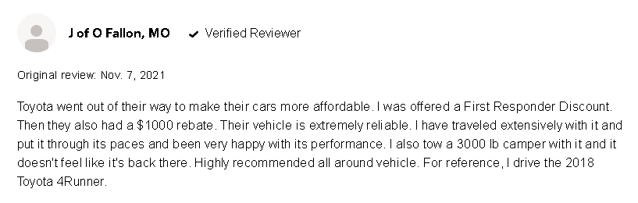. It was also found that Toyota did considerably well compared to other competitors during the on-going global pandemic. As seen below:

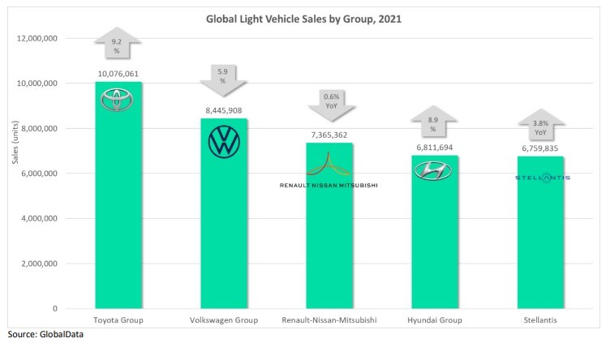

Toyota’s vehicles also come with a variety of features such as remote air-conditioning, a smart-key system head-up display, Dynamic Radar Cruise Control, and star safety system to name a few. These features in addition to its durability and affordability are what make Toyota one of the leading car brands. Factoring in their sustainable environmental practices, which is seen as a contributing factor to their high performance and high sales revenue

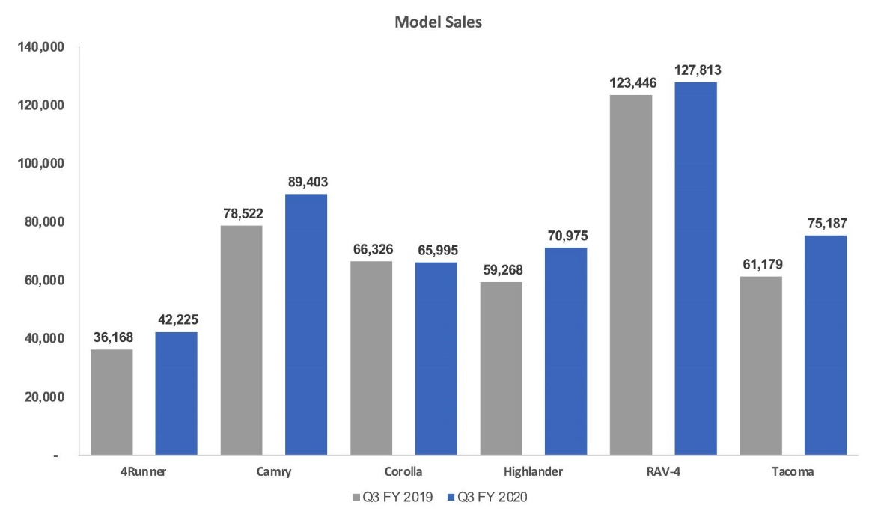

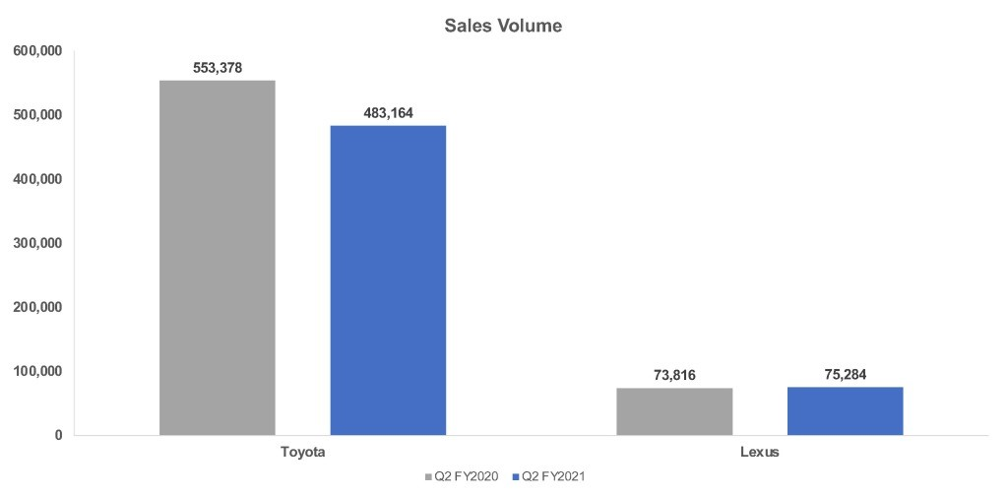Toyota and its subsidiary Lexus jointly sold 558,488 vehicles in the U.S. in the quarterly report, down 11% from the same period in 2019. That is a tad more than the decline for the industry in general, which was 10% lower than a year ago. As a result, Toyota’s overall market share dropped to 14.34% from 14.50% in the year-ago quarter.

The majority of the decrease was due to the Toyota brand, which sold 483,164 vehicles in the quarter, reduced to 13% from a year ago. However, Toyota experienced shortages of some popular models. As a result, Toyota’s market share dropped to 12.40% from 12.79%.

**5.2 Detailed process flow of Toyota**

I.*) Inputs*

The inputs for Toyota manufacturing are managed through inbound coordination. The raw material is procured through a set of arranged third-party vendors. The most important machinery and technology are obtained from the Japanese central workplace while different further raw materials are received from other sourcing countries. The assembly system has been put in place in such a way by Toyota so that its raw material can be further organized as per need and supplied to the plant from the warehouse. The assembly system is carried out so that inventory piling does not occur and raw material can be made handy as per need. There are 12 full-time workers deployed to control a plant inbound procedure while processing time is 6 hours to control the single consignment.

  II.*) Activities – Key operational production activities*

The main operational activities for Toyota production include transforming input raw material into the final product. The material in the production assembly line is managed through TPS (Toyota production system) by which each of the assembly lines help create the final product in the form of a vehicle. The part sequencing and setting up a schedule are done so that the right parts can arrive during the vehicle production and the complete process is done by enabling the pull system. The processing time is around 3 days to manage the production of 50 vehicles in one batch and takes deployment of 35 full-time employees.

III.*) Output*

The final output from the Toyota plant is the vehicle that is ready to get dispatched to dealers so that customers can purchase them directly from retail outlets. The output process goes through quality parameters while ensuring logistic of vehicle is done through providing proper safety measures to manage the similar quality of vehicle till it reaches dealer location. The final output, i.e., vehicles, are delivered through sealed containers to the dealer location. There are around seven full time employees deployed to manage one consignment of 50 vehicles so that quality control, dispatch of vehicle and logistic arrangements are done from the plant. The rest of the activities once the vehicle reaches the dealer's location are out of scope for the company.

1. **Discussion**

In light of the literature review, it can be observed that with quality input such as the quality car parts affect the output and customer satisfaction, in the case of Toyota motor corporation, and organized processing assembly lines the company is able to produce high-quality vehicles and hit its target customer base (low-income earners) without the quality of the vehicles deteriorating as they attempt to meet the demand and expectations of customers. Customer satisfaction is at a favorable level as automobile companies, in particular, Toyota as they meet both customers environmental concerns as they try to reduce their impact on their surroundings during production and the customers vehicle requirements and preferences. Evident in the reviews of the company's vehicle reviews. This clearly highlights the importance of a good open system and management and how these determine input quality, processing effectiveness and output quality for customer satisfaction.

1. **Conclusion**

Therefore, the combination of the decomposition of the supply chain in terms of employment and value-added allows for determining relevant differences in the cost structures within the supply chains. The result of this transformation is the organizational output: the products and services that follow from recurring and patterned activities that regulate the flow between input and output the importance of input-output models relate to how they are used to study three types of impacts namely, direct impact, indirect impact, and induced impact. Commonly the process begins with the gathering of raw materials and transforming them into vehicle parts to be used in assembly. How input influences output /performance the definition of organizational performance is a surprisingly open question with few studies using consistent definitions and measures. The output of the business/organization is used to gauge the performance of the business. In other words, the input of the business also influences the performance of the business. In addition, the company's input processes are a factor in the output level and customer satisfaction. There are 3 types of impact that the input can have on the output, they are direct impact, indirect impact, and induced impact. The quality of input units also affects output and customer satisfaction. For instance, if vehicles are made with Cheaper weak materials this will affect the quality of the cars and will result in a decrease in loyalty among customers. Finally, the induced impact is the tertiary result of how employees at the dealership will receive less income and can thus spend less money elsewhere. The definition of organizational performance is a surprisingly open question with few studies using consistent definitions and measures.

**8. References**

Pfeffer, J., & Salancik, G. (2003). *The external control of organizations*. Stanford, CA: Stanford University Press.  
Hassard, J. (1995). *Sociology and organization theory: Positivism, paradigms and postmodernity*. Cambridge, UK: Cambridge University Press. doi:10.1017/CBO9780511557651.

Katz, D., & Kahn, R. L. (1978). *The social psychology of organizations* (2nd ed.). New York, NY: John Wiley.

Scott, R. W. (2003). *Organizations: Rational, natural, and open systems* (5th ed.). Upper Saddle River, NJ:

Wright, P. M., & McMahan, G. C. (1992). Theoretical perspectives for strategic human resource management. *Journal of Management*, *18*(2), 295–320. doi:10.1177/014920639201800205.

Wright, P. M., & Snell, S. A. (1991). Toward an integrative view of strategic human resource management. *Human Resource Management Review*, *1*(3), 203–225. doi:10.1016/1053-4822(91)90015-5.

winth, R. L. (1974). *Organizational systems for management: Designing, planning and implementation*. Columbus, OH: Grid.

Ackerman, N (no date), *How Does Input & Output Work?,* Available at: <https://study.com/learn/lesson/input-output-model-importance-examples-economics.html> (02/06/2022).

Kirby, J. (2005). Toward a theory of high performance. *Harvard Business Review*, 83: 30–39.

Richard, P. J. et al. (2009) ‘Measuring Organizational Performance: Towards Methodological Best Practice’, *Journal of Management*, 35(3), pp. 718–804. doi: 10.1177/0149206308330560.

Cox Automotive (2020) *Cox Automotive Analysis: Toyota’s Q2 FY2021 U.S. Market Performance*. Available at: <https://www.coxautoinc.com/market-insights/cox-automotive-analysis-toyotas-q2-fy2021-u-s-market-performance/> (Accessed: 4 june 2022).

Roads Captain (2022) *Why Toyota leads the global automotive sales chart.* Available at: <https://roadscaptain.com/why-toyota-leads-the-global-automotive-sales-chart/> (Accessed:4 june 2022).

Britannica, T. Editors of Encyclopaedia (2021, May 22). *Toyota Motor Corporation. Encyclopedia Britannica*. https://www.britannica.com/topic/Toyota-Motor-Corporation.

Alshehri, O. (2016). Toyota process flow analysis. *Global Journal of Management and Business Research: Administration and Management.*

Bekerom, P. V. D., Schalk, J., & Torenvlied, R. (2017).Transforming Input Into Output: How Downward Networking Mediates the Effect of External Networking on Organizational Performance. *Public Performance & Management Review, 40 (4), 1-5. Available at:* [*https://doi.org/10.1080/15309576.2017.1305910*](https://doi.org/10.1080/15309576.2017.1305910) *.*

Pasinetti, L. L. (1977) *Lectures on the Theory of Production*. Columbia University Press.

Pasinetti, L. L. (1981) *Structural change and economic growth*. Cambridge: Cambridge University.

Zambelli, S., Fredholm, T. and Venkatachalam, R. (2017) ‘Robust measurement of national technological progress’, *Structural Change and Economic Dynamics*. Elsevier B.V., 42, pp. 38–55. doi:.

Fana, M., & Villani, D. (2021). *The Automotive Supply Chain in Europe: An Input-Output Analysis of Value Added and Employment Composition. Seville: European Commission.* <https://joint-research-centre.ec.europa.eu/document/download/e207be4c-54d1-413e-b777-e3bb746a4ed9_en.>

Shaikh, A. (2016) *Capitalism. Competition, conflict, crises*. New York: Oxford University Press.